**E115 – Programming and Data Analysis**

**Individual log sheet for Week 08**

1. List down all the questions that your team wants to ask in the survey, based on Project 3 requirements.

|  |  |
| --- | --- |
| **Category** | **Survey question** |
| A  (General information) |  |
|  |
|  |
|  |
|  |
| B  (Online ticket booking website) |  |
|  |
|  |
|  |
| C  (Check-in counter) |  |
|  |
|  |

1. Each team member will choose 2 survey questions from the table above to work on. Every member should be working on different survey questions, and one of the questions should be a rating question (i.e. question with a * marked in Project_3.docx).
2. Create a UserForm with a “Submit” button to write the passenger’s answer for your questions into the Excel sheet.
3. Add a “Clear” button to clear all the information in your UserForm.
4. Collect at least 10 sets of data using your UserForm.

[*Going further…*]

How do you prevent passengers from seeing the data submitted by other passengers when they are doing the survey?

Option 1:

Hide the sheet that contains survey data (E.g. Sheet1) using the following command. Passengers will not be able to unhide it.

Sheets("Sheet1").Visible = xlVeryHidden

Option 2:

1. Make UserForm big big so that it covers the entire Excel sheet.
2. Don’t allow passengers to close the UserForm.

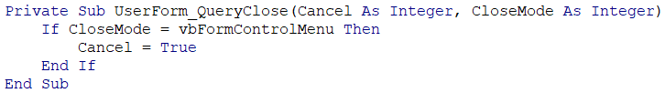

1. Don’t allow passengers to move the UserForm to another position.

